ASSESMENT TOOL -CO1 AT3
BY: HARIHARAN B (192511394)

Q1: Write a C program that takes an array as input and returns it reversed.

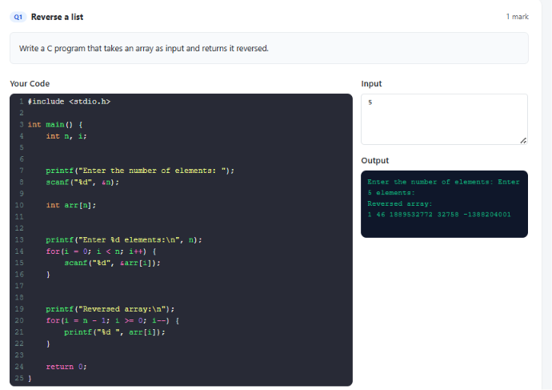
Q2: Write a C program for palindrom

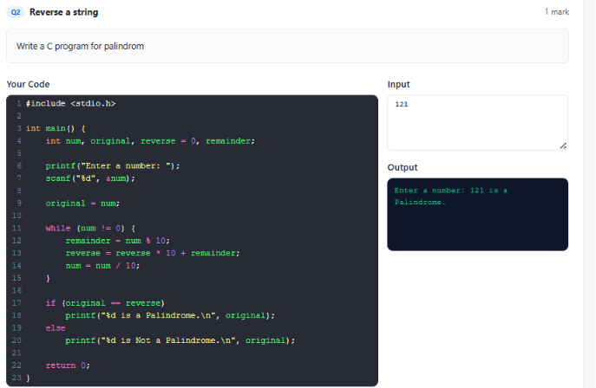

Q3: Write a C program for Searching an Element in a Sorted Array

